**Bank Machine System -**

**Part C (Group 1)**

**Bren Baga** 300726788

**Bryan Maravilla** 300870223

**Bassem El-Khechen** 300834362

**Jingyu Mei** 300845475

**Rhozando Pryce** 300846398

**Entity-Relationship Diagram**

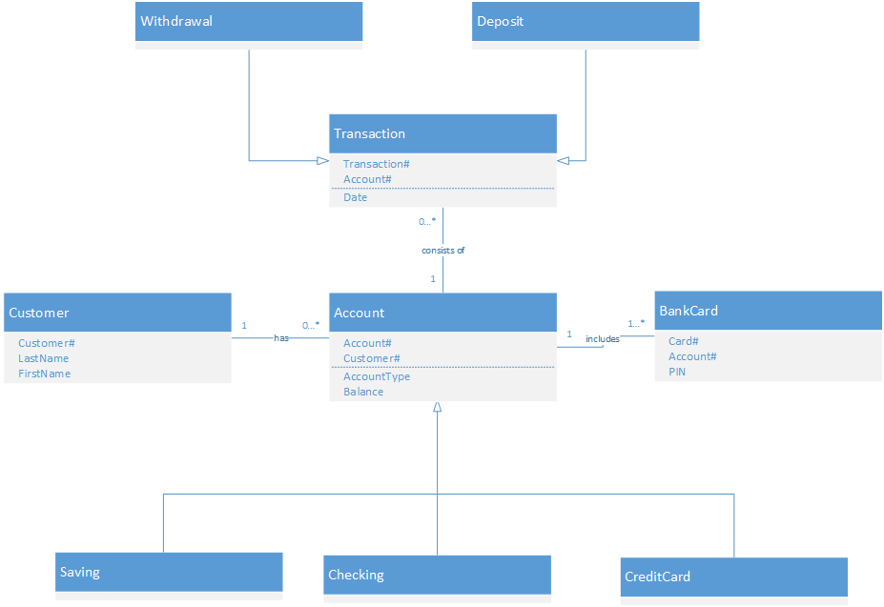

**Table Structure**

Table Name: **Customers**

|  |  |  |
| --- | --- | --- |
| Attribute | Key Type | Data Type |
| Customer# | Primary Key | Integer |
| LastName |  | Text |
| FirstName |  | Text |

Table Name: **Account**

|  |  |  |
| --- | --- | --- |
| Attribute | Key Type | Data Type |
| Account# | Primary Key | Integer |
| Customer# | Foreign Key | Integer |
| AccountType |  | Text |
| Balance |  | Integer |

Table Name: **Transaction**

|  |  |  |
| --- | --- | --- |
| Attribute | Key Type | Data Type |
| Transaction# | Primary Key | Integer |
| Account# | Foreign Key | Integer |
| Date |  | Date |

Table Name: **BankCard**

|  |  |  |
| --- | --- | --- |
| Attribute | Key Type | Data Type |
| Card# | Primary Key | Integer |
| Account# | Foreign Key | Integer |
| PIN |  | Integer |

**Table Cardinality (Relationships)**

|  |  |  |  |
| --- | --- | --- | --- |
| Table Name | Relationship | Cardinality | Table Name |
| Customer | has | 1:M | Account |
| Account | includes | 1:M | BankCard |
| Account | consists of | 1:M | Transaction |
| Saving | Inherits from | n/a | Account |
| Checking | Inherits from | n/a | Account |
| CreditCard | Inherits from | n/a | Account |
| Withdrawal | Inherits from | n/a | Transaction |
| Deposit | Inherits from | n/a | Transaction |

**State Machine Diagram**

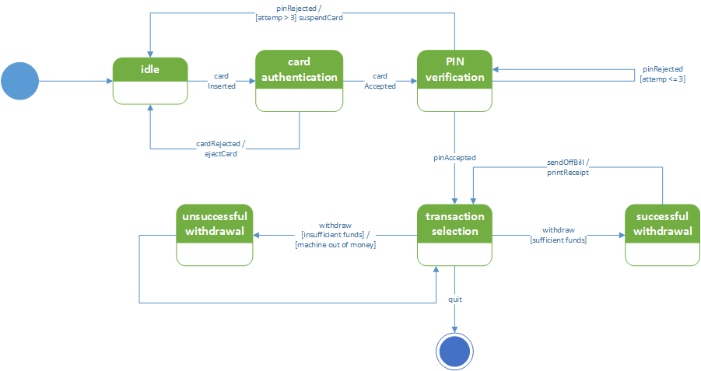

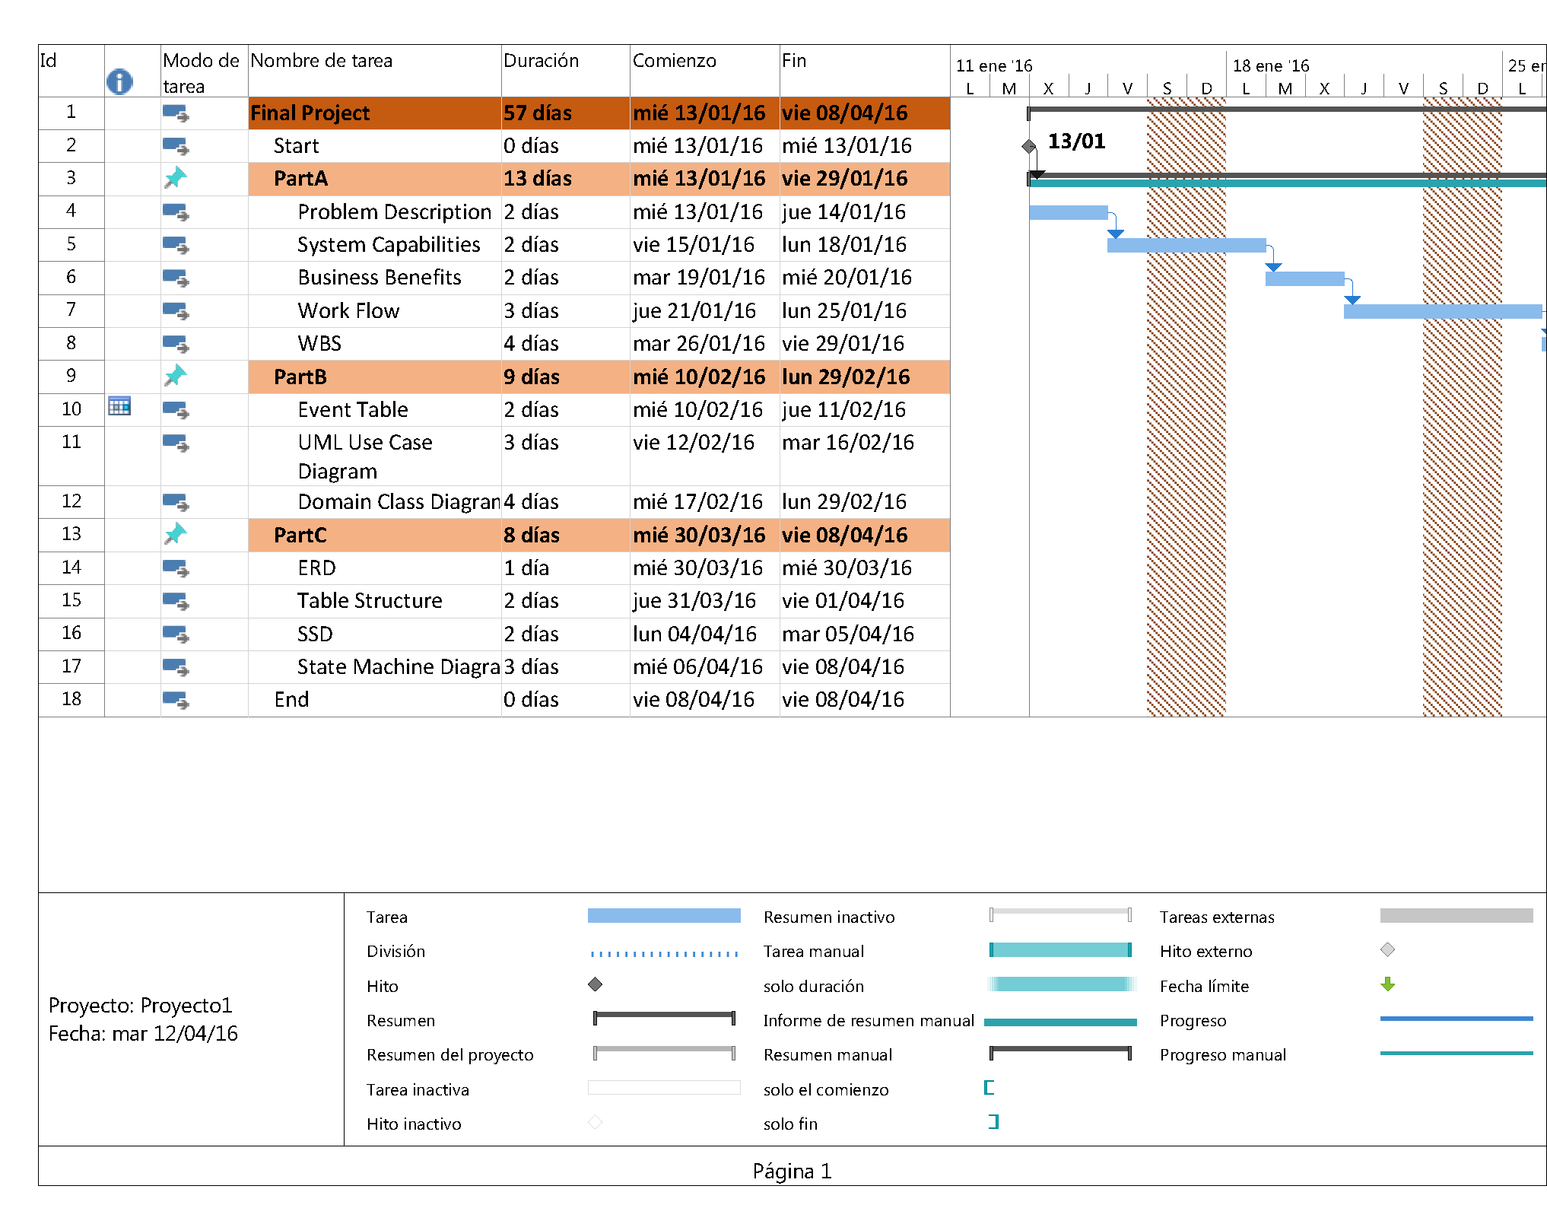**Gantt Chart**

